Instructions on creating Midwest Internet Mail Settings in Windows Vista:

In previous versions of Windows, the default mail client was Outlook Express. In Vista, it is now called Windows Mail.

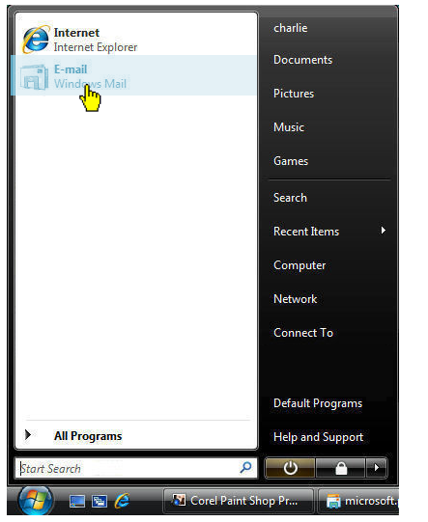

Click on the Start button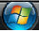, and at the top left, click on “Windows Mail.”
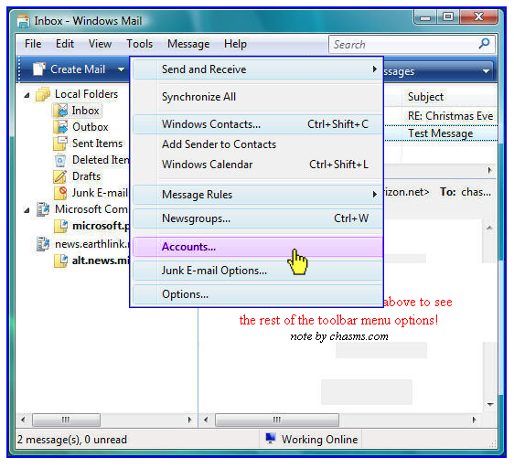
From the top menu on the Windows Mail screen, click on “Tools”, then “Accounts.”

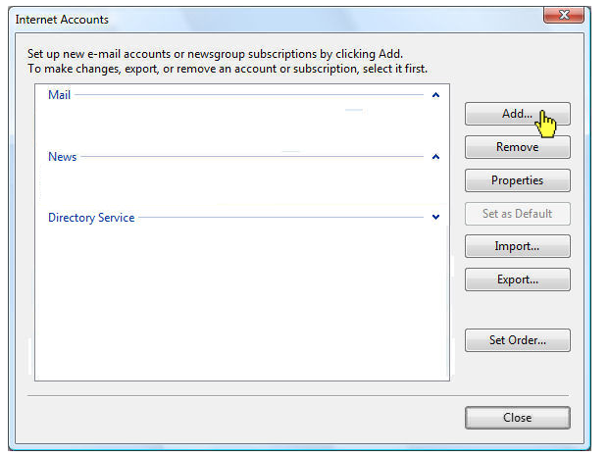

Click on the “Add” button, then select E-Mail Account. Click on “Next.”

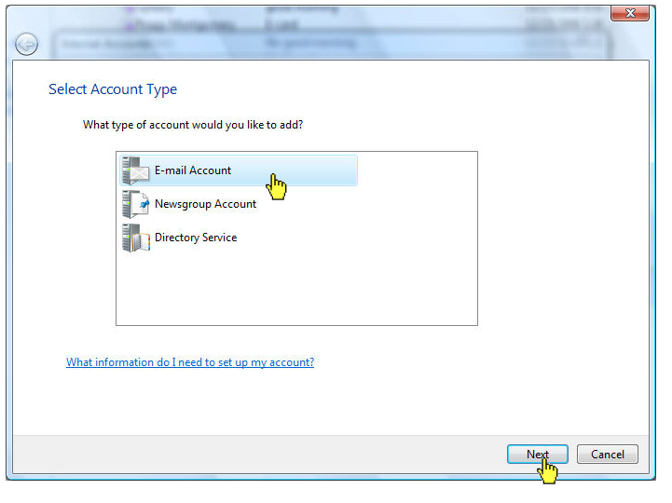

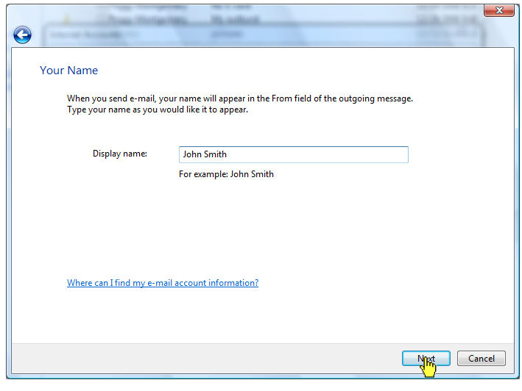
In the “Your Name” field, type in your name in upper and lowercase letters, much the same as you would type it in a letter. Click “Next.”

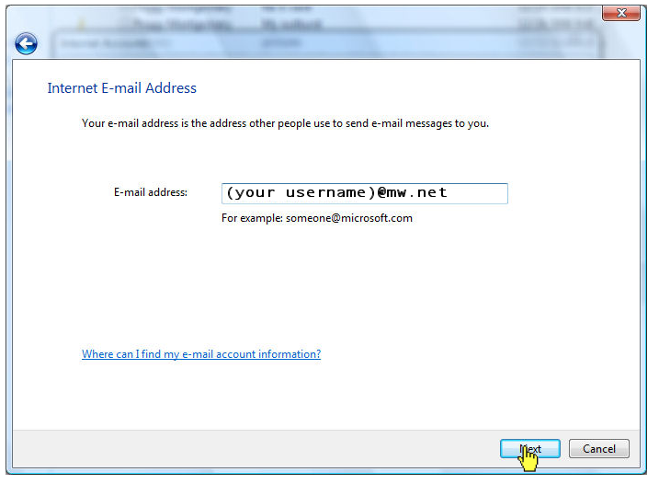
Next field is for your email address. Type in your username, followed by @mw.net.
Click “Next.”

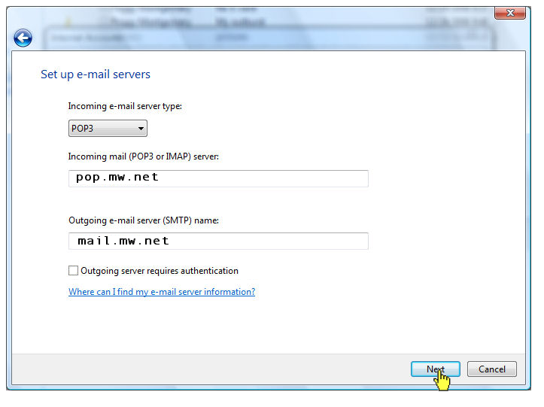
You’ll have three fields before you:

First one will say, “My incoming mail server is a POP3 Server.” Leave that one alone.

Second one will say incoming mail server: Type in pop.mw.net

Third will say outgoing mail server: Type in mail.mw.net

Click “Next.”

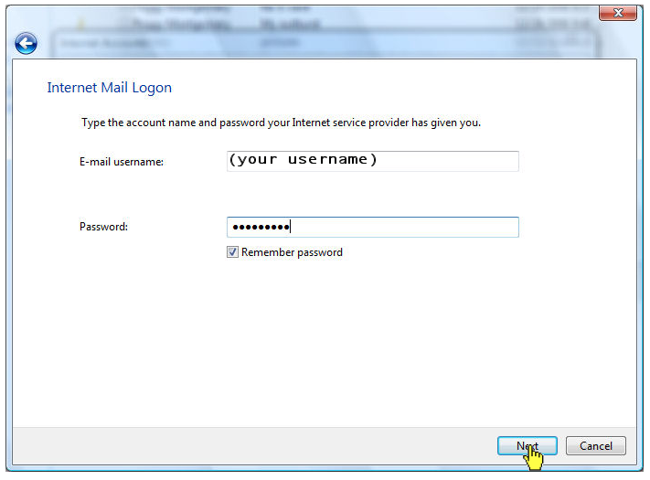

Your username will appear. Type in your password in the field provided. Click “Next.”

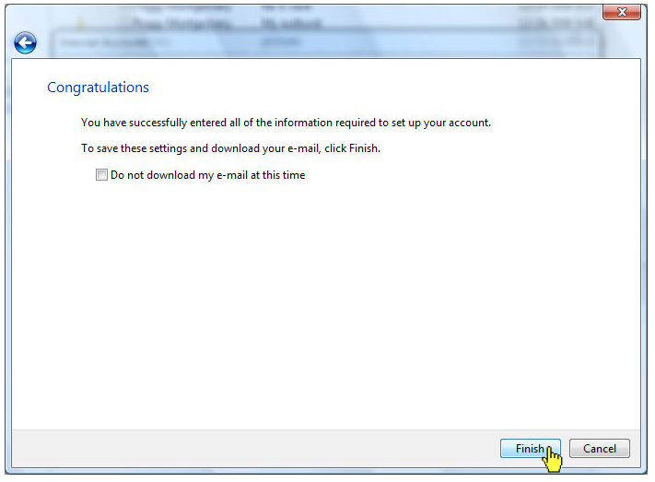
Windows Mail will say you have successfully created your mail account. Click “Finish.”

Click “Close.”

Your computer is now configured to send and receive Midwest Internet email.

